Datum: 30. 6. 2015 | Projekt OBOGATENO UČENJE TUJIH JEZIKOV 2013-15

Šola | Gimnazija Ptuj
Avtor 1 | Manja Bratuž | angleščina | 50
 | Priimek in ime | Predmet | Delež avtorstva (%)
Avtor 2 | Benjamin Tweedie | angleščina | 50
 | Priimek in ime | Predmet | Delež avtorstva (%)

Priloga 3

- Opis priloge

Vrsta | Priprava na pouk z refleksijo oz. evalvacijo izvedbe  Učno gradivo z refleksijo  Priporočila za učitelje
Datum nastanka  (d/m/l ali vsaj šolsko leto) | 22. 1. 2015
Ciljna skupina  (komu je gradivo namenjeno oz. kdo ga je uporabil) | 2. letniki (2. D)
Datum/-i uporabe  (d/m/l ali vsaj šolsko leto) | 29. 1. 2015

Za vrsto priloge upoštevaje opredelitve iz spodnje preglednice:

Št. | Razvojno-raziskovalno delo:  KATEGORIJE AKTIVNOSTI | Vrste izdelkov: Priloge
 | Vodenje šolskega projektnega tima (VPT) | - Načrt dela ŠPT  - Umestitev TU v ŠIK  - Načrt in evalvacija internih usposabljanj  - Poročilo o poteku in rezultatih projekta  - Študija primera
 | Koordinacija pouka tujega jezika (KTJ)
 | Izvajanje timskega pouka s tujim učiteljem | - Priprava na pouk z refleksijo oz. evalvacijo izvedbe  - Didaktizirano učno gradivo z refleksijo o uporabi  - Navodila in priporočila za učitelje
 | Izvajanje timskega pouka (slovenski učitelji - razvijanje strokovne pismenosti v TJ)
 | Izvajanje timskega pouka (slovenski učitelji - medjezikovne povezave)
 | Organizacija modeliranj timskega pouka | - Program usposabljanja z modeliranjem timskega pouka s poročilom o izvedbi
 | Izvajanje modeliranj timskega pouka | - Priprava na pouk z refleksijo oz. evalvacijo izvedbe  - Didaktizirano učno gradivo z refleksijo o uporabi  - Delavnice za udeležence

- Poročilo o uporabi: Refleksija oziroma evalvacija*
*Ne velja za naslednje priloge: Načrt dela ŠPT, Poročilo o poteku in rezultatih projekta in študijo primera.

Presoja avtorja/avtorjev (vsakega posebej, če poučujeta različne predmete oz. se razhajata v mnenjih) o uspešnosti, učinkovitosti in prenosljivosti novosti oz. razvojne rešitve (skupaj 500-750 besed)

Refleksija avtorja 1 | Izziv je bil motivirati dijake za tematiko, ki je kot se je sprva zdelo, ne poznajo oziroma jih ne zanima. Sam angleški termin »sweatshops« je za dijake bil popolnoma nov, so pa že slišali za etično nakupovanje in trgovine. Učna ura je uspela saj so se dijaki s pomočjo različnih aktivnosti in diskusije med uro poistovetili s težavami izkoriščanih delavcev.  Cilji (usvojiti besedišče povezano z maturitetno temo, biti sposoben govoriti o njej in hkrati ozaveščati o globalnih problemih) so bili doseženi. Dijaki so bili motivirani sodelovati v diskusiji in pripravljeni razmisliti o svojih nakupovalnih navadah. Še posebej jih je presenetila predstavitev razmer v katerih delavci živijo in delajo in plačilo, ki ga dobijo.  Gradivo je bilo skrbno pripravljeno z namenom, da se dijaki čim bolj poistovetijo s problematiko. Namenoma sva se odločila za zvočni posnetek in ne video, da dijaki utrjujejo slušno razumevanje. Odločila sva se za predstavitev besedišča v obliki miselnega vzorca, nato prikaz avtentičnih primerov, ki so se dejansko zgodili. Delo v skupinah pa je dijake spodbudilo h kritičnemu razmišljanju in diskusiji.  Menim, da je zato gradivo, ki sva ga skrbno izbrala in pripravila, zelo primerno za predstavitev tematike in uporabno v različnih učnih okoljih.  Odlična tema za ozaveščanje o globalnih problemih.
Refleksija avtorja 2 | This lesson was well-received by the students who became quite animated at times. Whilst it initially appeared that the student cohort knew very little about the term “sweatshops”, upon further discussion it was discovered that this initial assumption was erroneous. For instance, some students were quite knowledgeable about the issue in that they tried to shop in an ethical fashion in relation to their clothing purchases. That is, they would try to purchase clothes from manufacturers who treated their workers more fairly. Ultimately, this lesson was a success since even the most fashion-conscious students indicated that they would (as a result of their participation in the lesson) try to be more reflective about future purchases.
Odzivi in menja drugih (tj. ciljne publike: učencev/dijakov, učiteljev, ravnatelja, udeležencev …) | Odziv dijakov je bil pozitiven, zadovoljni pa so bili tudi zato, ker so dejansko spoznali nekaj novega in začeli razmišljati o globalnih težavah o katerih prej mogoče niso.

 | LESSON PLAN FOR TEAM TEACHING

Subject: |  | English |  |  | Class: |  |  | 2. d |  | Date: | 29. 1. 2015 | Lesson: | 54 | Classroom: | 16
Teachers: |  | Benjamin Tweedie (FT) & Manja Bratuž (ST)
Topic: | Sweatshops
Content focus: |  |  | Culture: Should I be concerned about sweatshops?  Language: Content-relevant vocabulary and argumentation language structures.
Team teaching types: |  |  |  |  |  | dialogue, traditional, alternating & supportive
Teaching design: |  |  |  | teacher-led, individual & group work.
Teaching methods: |  |  |  | discussion, explanation, and exercise
Goals: | To sensitise the students to the issue of sweatshops.  To develop the students' argumentation skills about specific themes.
Expected Learning Outcomes: |  |  |  |  |  |  |  |  | The students will be able to identify the key issues relating to the concept of sweatshops.  The students will be able to verify whether they can use the argumentation language structures.
Teaching aids and materials: |  |  |  |  |  |  | for teachers: |  |  |  | whiteboard, markers, dictionary, computer, projector
 |  |  |  |  |  |  | for students: |  |  |  | hand-outs, pencils, pens, eraser
Prerequisite knowledge: |  |  |  |  |  |  | Students need to have already discussed the language structures which are used when making an argument.

TEACHING STAGES

TIME | TEACHER ACTIVITIES |  | STUDENT ACTIVITIES | ITP
 | ST | FT
3' | Checks student attendance. | Shows sweatshop image and asks students if anybody can explain the concept. | Students provide input either voluntarily or after being nominated by the teacher. | supportive
5' | Discusses the accuracy of the mind-map with the FT. | Displays the Sweatshops mind-map.  Discusses the accuracy of the mind-map with the ST. | Students observe discussion between the two teachers. | dialogue
7' | Discusses with students whether Slovenia has (or has had) sweatshops.  Asks students to reflect on whether they could survive on the displayed hourly wages. | Asks students whether they think the term Favella is ubiquitous.  Displays the tabulated data of average hourly wages for sweatshop workers. | Students provide input either voluntarily or after being nominated by the teacher. | supportive
10' | Monitors students’ on-task behaviour.  Elicits answers from students about the audio clip.  Outlines the “Nike Sweatshops” case study. | Introduces the case study of the “Rana Plaza Building Collapse”.  Plays the “Rana Plaza” audio clip.  Displays the listening comprehension questions.  Asks students to hypothesise what “Educating for Justice” discovered when they went to Indonesia. | Students listen to the audio and provide appropriate feedback. | supportive
10' | Distributes two stimulus images for each group.  Alternates between Groups 1 and 2 in order to monitor and facilitate the discussion. | Gives instructions for the group activity.  Alternates between Groups 3 and 4 in order to monitor and facilitate the discussion. | Students discuss the issues relevant to their allocated stimulus image in four small groups. | alternating
10' | Leads the feedback for groups 1 & 2.  Writes feedback on whiteboard. | Writes feedback on whiteboard.  Leads the feedback for groups 3 & 4. | Selected small group representatives provide feedback about their allocated stimulus image. | traditional

 | 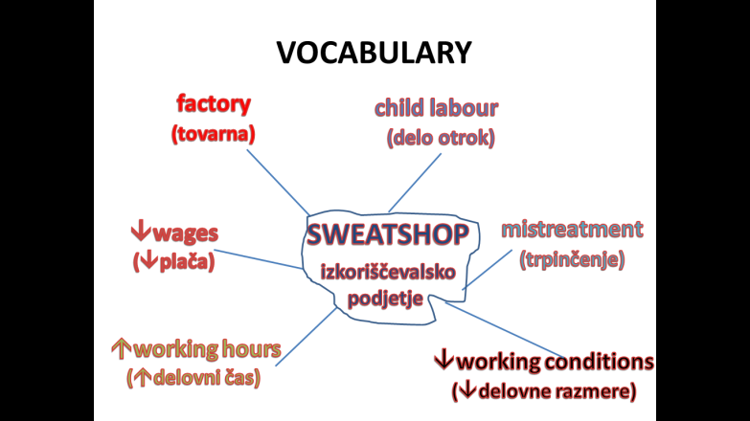
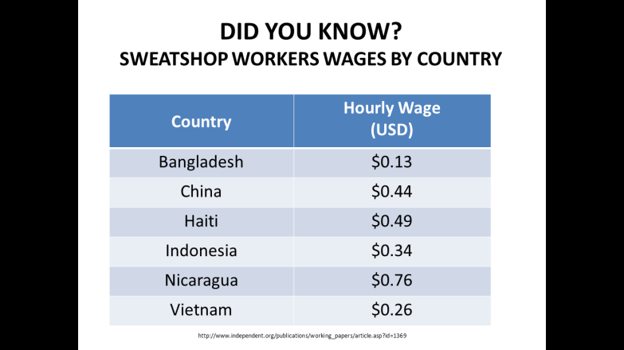 | 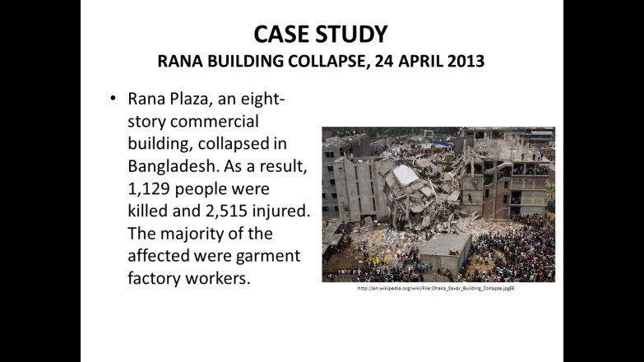
 | 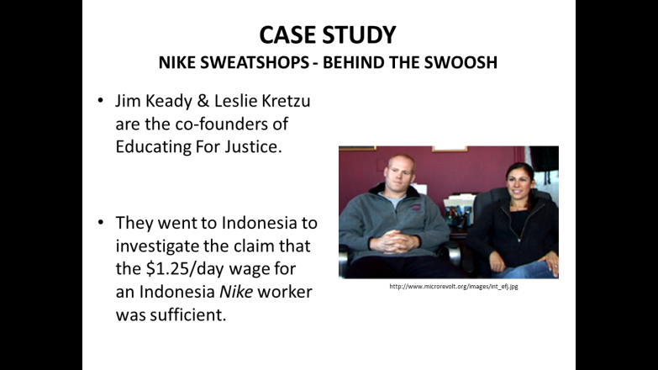
 | 

 | 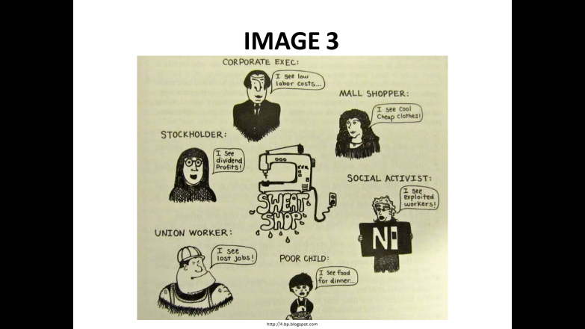
 | 
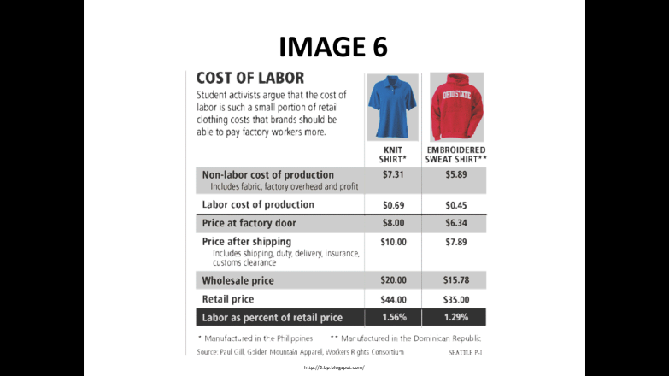 | 


